4662M
JERZEES
Super Sweats
Crewneck Sweatshirt

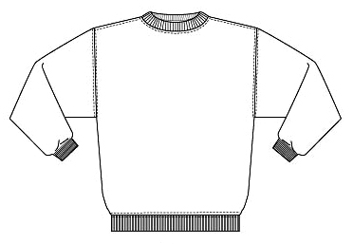

Descriptions
*50/50 poly cotton, 9 ounce NuBlend fleece
*Fully coverseamed
*Ribbed collar, cuffs & waistband with spandex
*Set in sleeves
*Embroidery or screenprinting okay

Finished Garment Measurements

Size | S | M | L | XL | 2XL | 3XL
Length | 27 | 28 | 29 | 30 | 31 | 32
Width | 20 | 22 | 24 | 26 | 28 | 30
Sleeve Length | 35 | 36 | 37 | 38 | 39 | 40

